Digital Electoral System for Chairperson Selection
Design Document

Version 1.0



Group Id: S2402AF044 (BC170201536)

Supervisor Name: Musaddiq Hussain

Revision History
Date (dd/mm/yyyy) | Version | Description | Author
08-07-2024 | 1.0 | This is a web application for online voting to select a chairperson for the university students, in which students of the university will get registered on the platform and cast vote to elect their favourite candidate. Interested university students can also register themselves and apply to participate as a candidate. An administrator will manage all the election process. He can approve/reject students’ registrations, approve/reject the applications of candidates and can generate and publish voting results/reports etc. | BC170201536

Table of Contents

- Introduction of Design Document
- Entity Relationship Diagram (ERD)
- Sequence Diagrams
- Architecture Design Diagram
- Class Diagram
- Database Design
- Interface Design
- Test Cases

- Introduction of Design Document
Design Document is a technical solution of the SRS. It serves as the blueprint of the system, which describes the design and architecture of the whole system. It includes:
- “Entity Relationship Diagram” which describes the conceptual design of the database, i.e. entities of the system, their attributes and relationships among them.
- “Database Design”, which describes the logical design of the database, which is then implemented in any DBMS.
- “Sequence Diagrams”, describing the sequence of events that occur among different objects and services of the system, to perform a specific functionality.
- “Architecture Diagram”, which describes the tiered architecture of the system.
- “Class Diagram”, which depicts the object-oriented design of the system. It describes the attributes and methods associated with each class, and also inheritance (conceptual link among classes) and association (physical link among objects) relationships.
- “Interface Design”, which describes the user interface / front-end view of the system to which user will interact.
- “Test Cases” for each use-case / usage scenario.
Design Document is a very critical phase of the SDLC. It outlines what needs to be built, and provide a clear understanding of the system to all stakeholders like testers, client and developers etc. Many potential risks are identified and mitigated in the design phase, before moving ahead. It serves as the blueprint for the developers and provide consistency and standardization during development. It helps testers to test a particular functionality efficiently and make effective test plans as it provides the complete design of the system. It is very beneficial for maintenance and scalability, because it provides the complete architecture and design of the system and helps that how a specific area can be maintained and scaled up. It helps in quality assurance as a review and feedback reference and avoid rework result in cost efficiency. Moreover, it helps project managers to allocate resources for each activity of the SDLC.
- Entity Relationship Diagram (ERD)
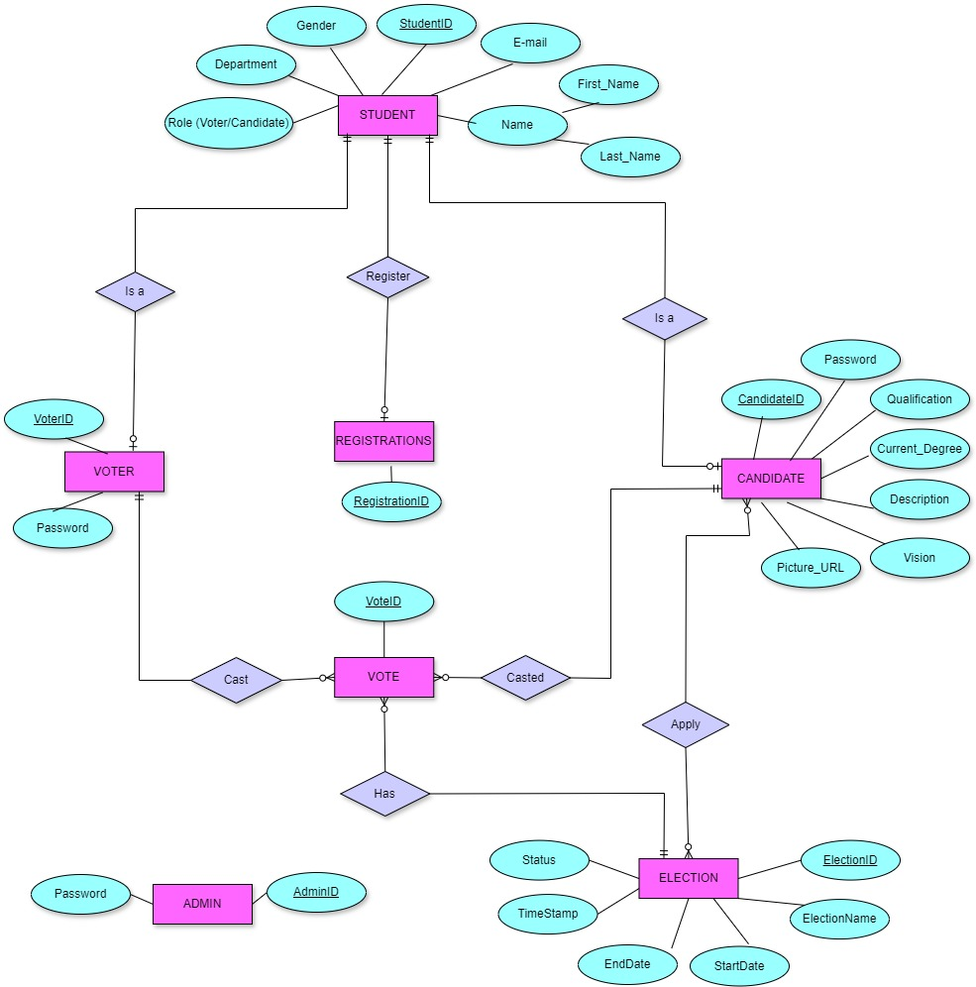
- Sequence Diagrams
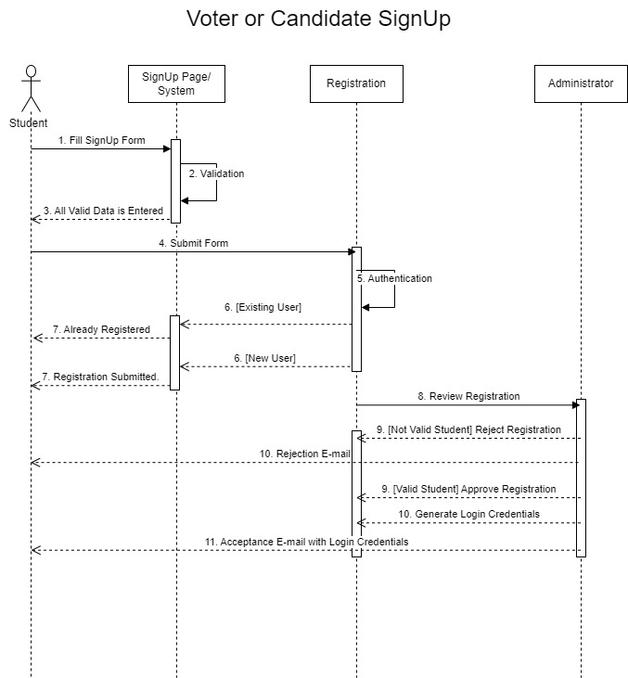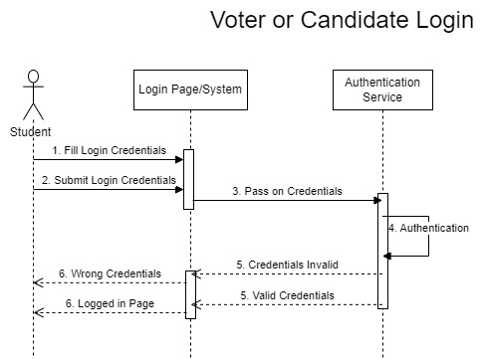

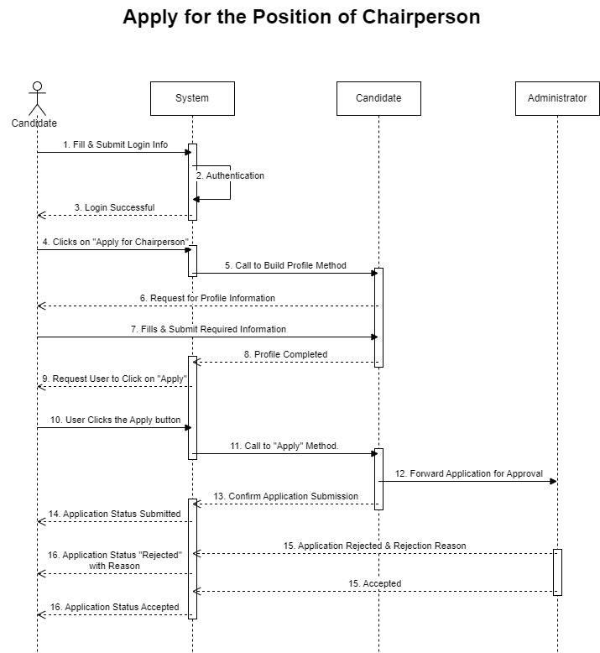

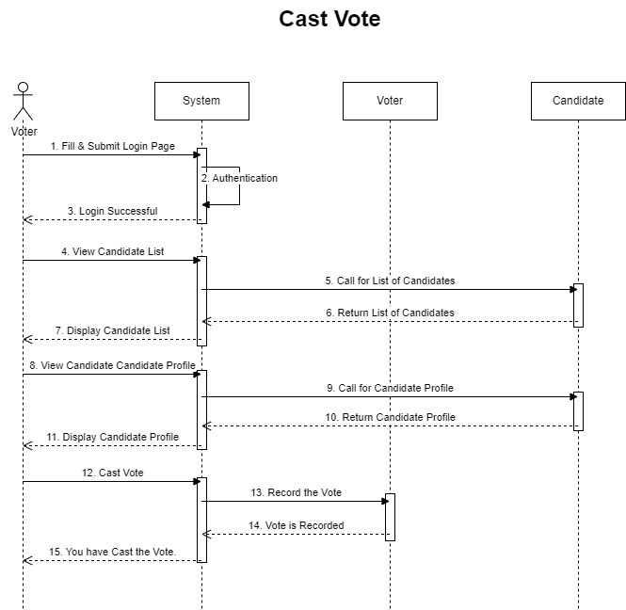

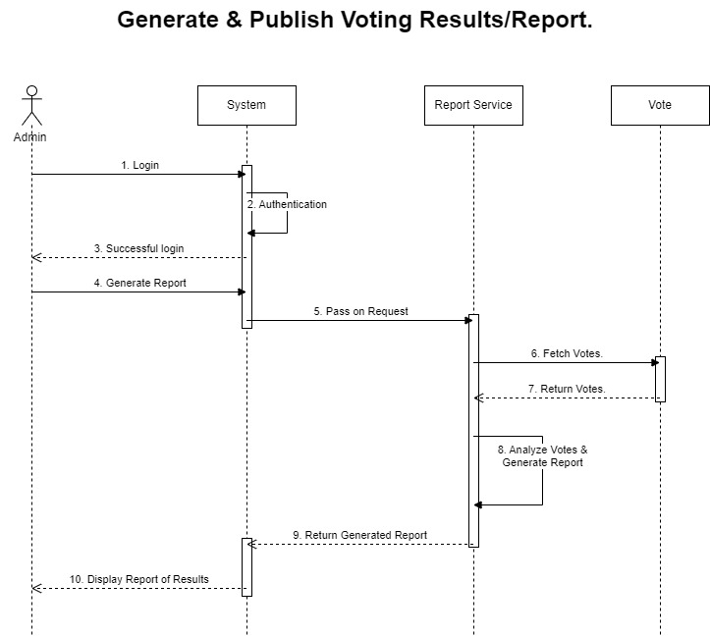
- Architecture Design Diagram
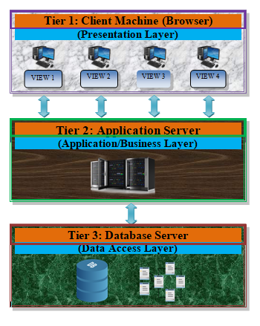
- Class Diagram

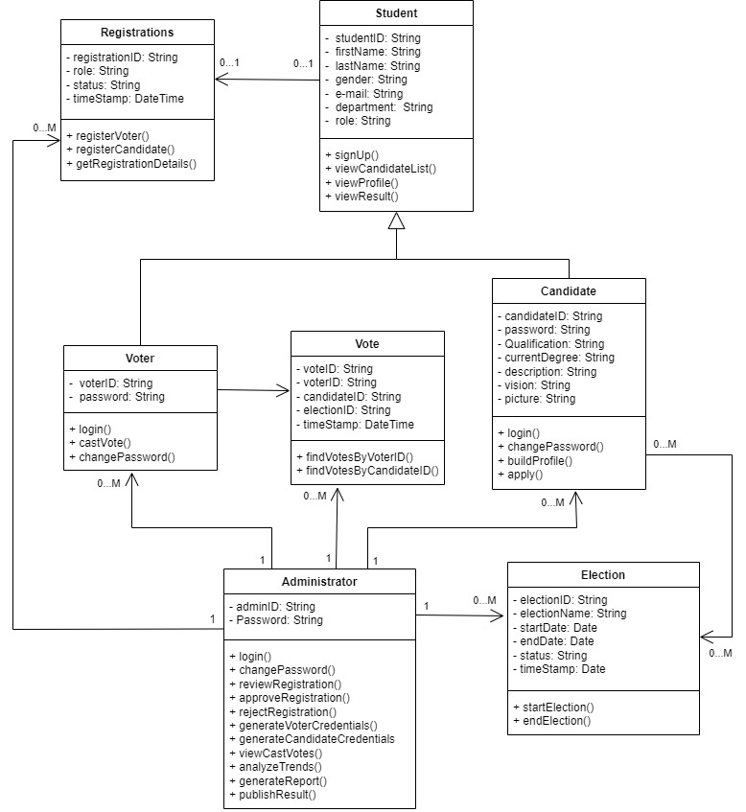

- Database Design

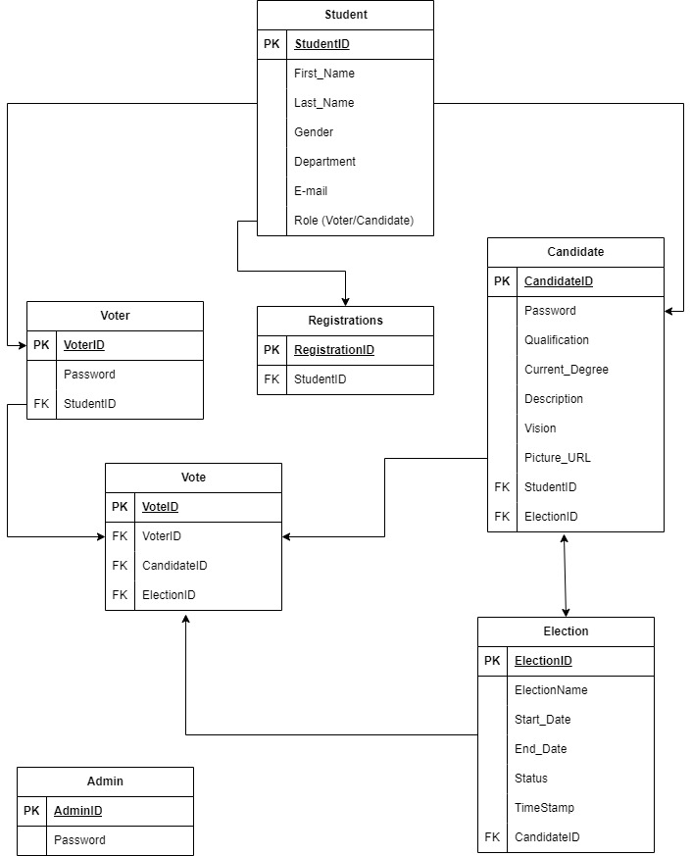
- Interface Design

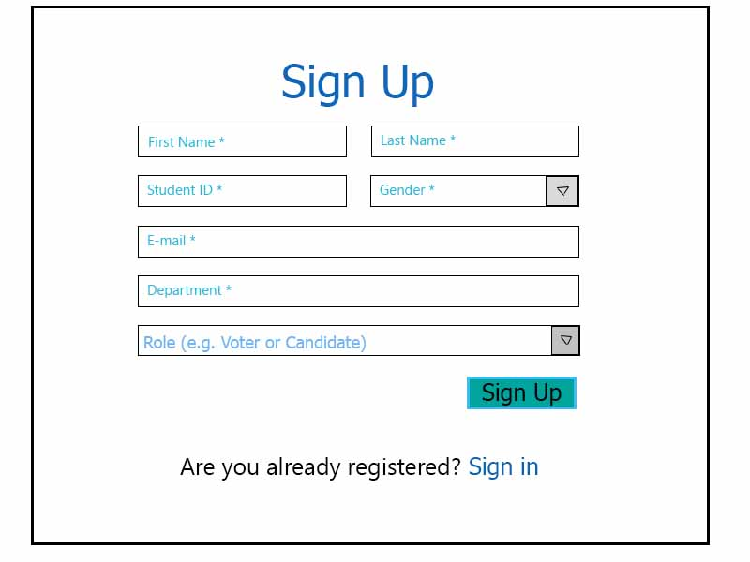

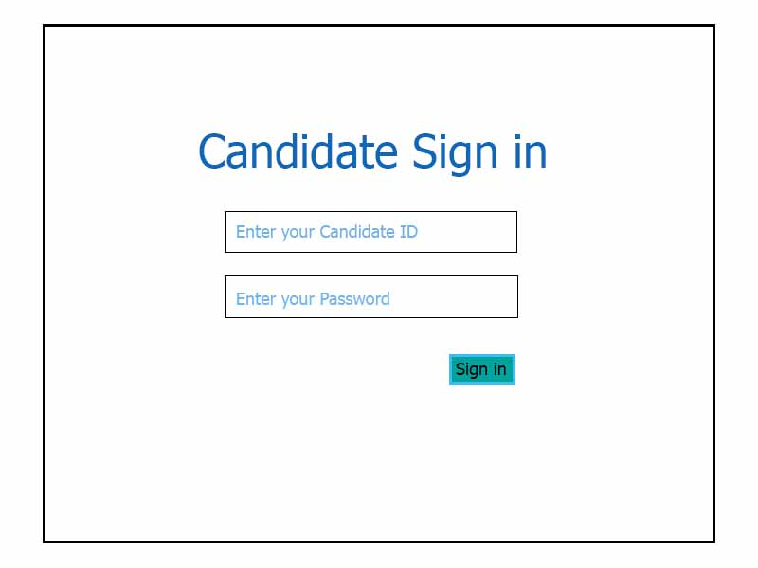

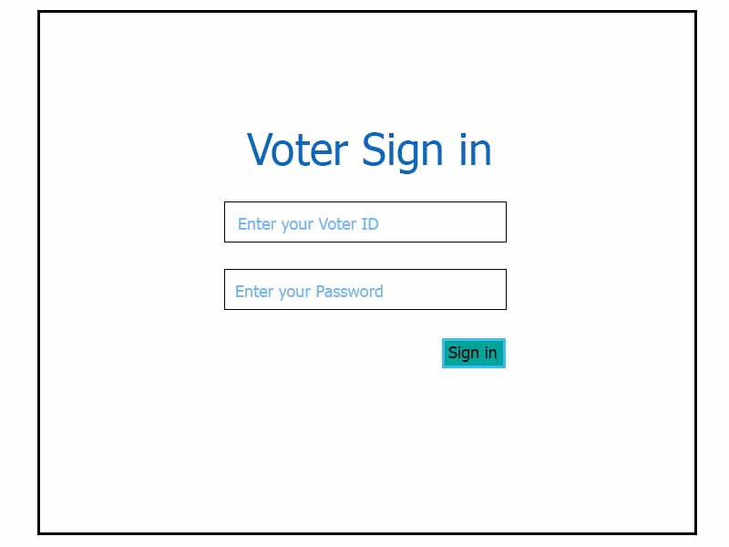



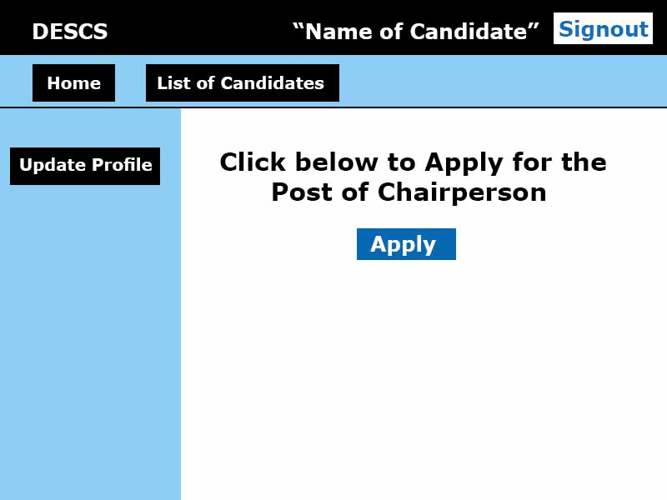

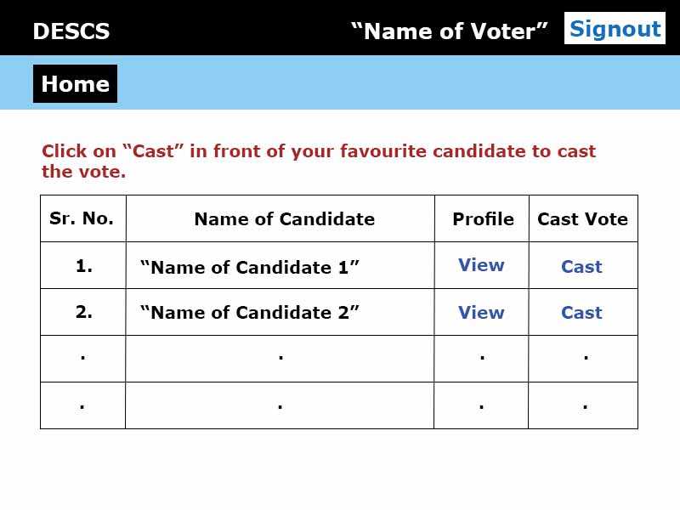

- Test Cases

Test Case # 1:
Test Case Title | Register as Voter
Test Case ID | TC-01
Pre-Conditions | None.
Actions | - Click on signup button  - Fill in signup form with correct details.  - Click on submit button.
Expected Results | Registration should be submitted and system should display the confirmation message.
Results | Pass/Fail
Author | BC170201536

Test Case # 2:
Test Case Title | Login as Voter
Test Case ID | TC-02
Pre-Conditions | Voter is Registered.
Actions | - Click on Login button.  - Enter correct Voter ID and Password.  - Click on submit button.
Expected Results | Voter should be successfully logged in.
Results | Pass/Fail
Author | BC170201536

Test Case # 3:
Test Case Title | Cast Vote
Test Case ID | TC-03
Pre-Conditions | Voter is successfully logged in to the system and vote is not already casted.
Actions | - View the list of candidates.  - Click on cast vote button in front of the favourite candidate.
Expected Results | Vote should be casted and system should display confirmation message.
Results | Pass/Fail
Author | BC170201536

Test Case # 4:
Test Case Title | Change Password
Test Case ID | TC-04
Pre-Conditions | Voter/Candidate is logged in
Actions | - User clicks on settings button  - User clicks on Change Password.  - User enters correct “Old Password” and “New Password”.  - User clicks on submit button.
Expected Results | Password should be changed successfully and system should display confirmation message.
Results | Pass/Fail
Author | BC170201536

Test Case # 5:
Test Case Title | Register as Candidate
Test Case ID | TC-05
Pre-Conditions | None.
Actions | - Click on signup button  - Fill in signup form with correct details.  - Click on submit button.
Expected Results | Registration should be submitted and system should display the confirmation message.
Results | Pass/Fail
Author | BC170201536

Test Case # 6:
Test Case Title | Login as Candidate
Test Case ID | TC-06
Pre-Conditions | Candidate is Registered.
Actions | - Click on Login button.  - Enter correct Candidate ID and Password.  - Click on submit button.
Expected Results | Candidate should be successfully logged in.
Results | Pass/Fail
Author | BC170201536

Test Case # 7:
Test Case Title | View List of Candidates
Test Case ID | TC-07
Pre-Conditions | None
Actions | - Any user opens the homepage of the website.  - Clicks on “List of Candidates” tab on the homepage.
Expected Results | System displays the list of candidates.
Results | Pass/Fail
Author | BC170201536

Test Case # 8:
Test Case Title | View Candidate Profile
Test Case ID | TC-08
Pre-Conditions | List of Candidates is displayed on the screen.
Actions | User clicks on the name of any candidate.
Expected Results | Candidate Profile should be displayed on the screen.
Results | Pass/Fail
Author | BC170201536

Test Case # 9:
Test Case Title | Build Profile
Test Case ID | TC-09
Pre-Conditions | Candidate is logged in to the system.
Actions | - Candidate clicks on “Profile” button.  - Candidate fills in all the required profile information.  - Candidate clicks on update button.
Expected Results | Profile information should be saved/updated and system should display confirmation message.
Results | Pass/Fail
Author | BC170201536

Test Case # 10:
Test Case Title | Apply for the Position of Chairperson
Test Case ID | TC-10
Pre-Conditions | Candidate is successfully logged in to the system.
Actions | - Candidate clicks on “apply for chairperson” button.  - Candidate builds profile and clicks on update button. (In case, if profile is not built previously)  - Candidate clicks on apply button.
Expected Results | Application should be submitted, pending approval by the admin and system should display the confirmation message.
Results | Pass/Fail
Author | BC170201536

Test Case # 11:
Test Case Title | Login as Administrator
Test Case ID | TC-11
Pre-Conditions | Admin ID and Password has been created for Administrator.
Actions | - Admin enters correct login credentials  - Clicks on submit button.
Expected Results | Administrator should be successfully logged in to the system.
Results | Pass/Fail
Author | BC170201536

Test Case # 12:
Test Case Title | Review Registrations
Test Case ID | TC-12
Pre-Conditions | Administrator is logged in to the system and there must be pending registrations.
Actions | - Admin accesses the pending registrations page.  - Admin clicks on any one of the registrations.
Expected Results | System should display all the submitted data, relevant to the registration, for review.
Results | Pass/Fail
Author | BC170201536

Test Case # 13:
Test Case Title | Approve or Reject any Registration
Test Case ID | TC-13
Pre-Conditions | Administrator has accessed the registrations page after logging in to the system.
Actions | - Administrator clicks on any registration and review it.  - Administrator clicks on “Approve” button to approve the registration or on “Reject” button to reject it.
Expected Results | On clicking the Approve or Reject button registration should be approved or rejected respectively.
Results | Pass/Fail
Author | BC170201536

Test Case # 14:
Test Case Title | Generate Voter ID and Password
Test Case ID | TC-14
Pre-Conditions | Administrator has approved the registration of the voter.
Actions | - Administrator generates unique voter ID and password for the voter.  - Administrator sends that voter ID and password to the voter’s  e-mail.
Expected Results | Unique Voter ID and Password should be generated and sent to the voter’s e-mail.
Results | Pass/Fail
Author | BC170201536

Test Case # 15:
Test Case Title | Generate Candidate ID and Password.
Test Case ID | TC-15
Pre-Conditions | Administrator has approved the registration of the candidate.
Actions | - Administrator generates unique Candidate ID and Password for the candidate.  - Administrator sends that Candidate ID and Password to the candidate’s e-mail.
Expected Results | Unique Candidate ID and Password should be generated and sent to the candidate’s e-mail.
Results | Pass/Fail
Author | BC170201536

Test Case # 16:
Test Case Title | View Votes Casted
Test Case ID | TC-16
Pre-Conditions | Administrator is logged in to the system.
Actions | - Administrator clicks on voting results button on the menu bar.  - Administrator clicks on the name of any candidate from the displayed list of candidates.
Expected Results | System should display the votes casted against the candidate.
Results | Pass/Fail
Author | BC170201536

Test Case # 17:
Test Case Title | Generate Reports of Results
Test Case ID | TC-17
Pre-Conditions | Administrator is logged in and votes must have been cast.
Actions | - Administrator accesses the voting results page.  - Administrator generates report of result i.e. total voter turnout, department wise turnout, winner of the election.
Expected Results | Report is generated and displayed on the screen of administrator.
Results | Pass/Fail
Author | BC170201536

Test Case # 18:
Test Case Title | Publish Report
Test Case ID | TC-18
Pre-Conditions | Administrator is logged in and has generated the report of results.
Actions | - Administrator accesses the report of results.  - Administrator clicks on publish button.
Expected Results | The report should be published and system should display confirmation message that report has been published. While clicking the “Results” tab on the homepage of the website, the published report should be displayed.
Results | Pass/Fail
Author | BC170201536

